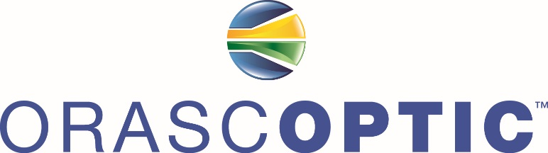

**PEACE OF MIND WARRANTY  
*LET US WORRY ABOUT YOUR LOUPES, SO YOU CAN FOCUS ON SCHOOL***

* **Industry Leading Resolution**: guaranteed edge to edge clarity
* **Customized Full Digital Measurements**: working distance measured to ½ inch, maximum declination angles available
* **No charge for Rx** in Optics and Carrier Lenses
* **45 Day Trial Period** – If you don’t like what you get, you can change it or return it for a refund.
* **Lifetime Telescope Warranty**: including optical seals, Waterproof Optics !
* **Unlimited Frame Repairs** while in school, including temple arm replacements if needed.
* **LED Headlights**: LED Optic, headlight cables can be replaced free of charge while in School
* **On site regularly Scheduled Service visits with local Rep. Gregg Brown**
* **Gregg Brown has 25 years experience** servicing Dental Magnification Systems
* **Dedicated Customer Care and Technical support team : Prompt, Professional, Service !**
* **Free**  Working Distance change while in School
* **Free** Prescription Change while in School
* **Free 1** infection control and Refurbishment Service
* **Free**  Accessories: curing filter, side shields, head strap, nose pads, temple arms
* **Free….. Loaner Loupes / Light to be provide to your class Supply Rep.**

**University @ Buffalo Dental School Pricing**

HDL 2.5x Loupe/ Light Combo starting at $1425.00 + tax

* 3, 6 or 9, Month Interest Free Payment Plans
* (6) equal payments of $237.50 or (9) equal payments of $158.33
* FREE Shipping on all Orders

